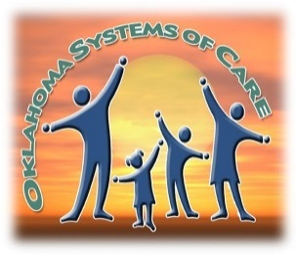
Edwin Fair Community Mental Health Center Systems of Care
-------Youth 4 to 21 years of age-------
Health Home Enrollment

Site: Enrollment Date: / /
Youth Name: Date of Birth: / /
Gender: Female Male Member ID #:
Social Security #: Is this a Young Adult in Transition? Yes
OKDHS KK #: (if OKDHS involved)
Child Protective Services Family Centered Services Permanency Planning
OJA #: (if OJA involved)
Race / Ethnicity: (Check all that apply.)
White Black / African American American Indian Hispanic / Latino
Asian Other (Specify):
If Latino, which group describes her/his cultural background?
Mexican / Mexican-American Puerto Rican Cuban
Dominican Central American South American Other (Specify):
If American Indian, please indicate:
Enrolled Tribe: Other Tribal Identification
Caregiver Name: Relationship to Child:
Address:
City: County: State: Zip Code:
Home Phone: Work Phone: Cell Phone:
School: School Phone:

Youth Risk Factors (please check all that apply)

Runaway / leaving home without permission | Chronic illness
Withdrawal from family, social activities | Self-harming behavior
Recent dramatic changes in eating habits, sleep pattern or body weight | Repeated incidents of lying, stealing, property destruction
Age or developmentally inappropriate bed-wetting or soiling | Physical aggression toward authority figures, family members, peers
Inappropriate sexual behavior | Intentionally hurts others
Perpetrator of sexual abuse | Intentionally hurts animals
Victim of sexual abuse | Sets fires
Victim of physical abuse | Involvement in criminal activity
Use or abuse of alcohol or drugs | Declining school grades, truancy, poor attendance
Attempted suicide or suicidal thoughts | School suspensions / expulsions
Hallucinations – aural, visual or tactile | Developmental delays
History of inpatient psychiatric hospitalization(s) | History of neglect

Caregiver / Family Risk Factors (please check all that apply)

Chronic physical illness in family | Parental incarceration
Family history of mental illness, psychiatric hospitalization or substance abuse | History of domestic violence
Suicide attempts | Poverty
Victim of physical abuse (other than youth) | Other children in foster care
Victim of sexual abuse (other than youth) | Youth exposed to substance abuse in the home

Trauma Factors (please check all that apply)

Car accident |  | Verbal / emotional abuse
 | Other _______________________________ | Physical assault
 | Fire | Sexual assault
 | Storm | Death of a close friend or relative
 | Victim of bullying | Divorce of parent/caregiver

