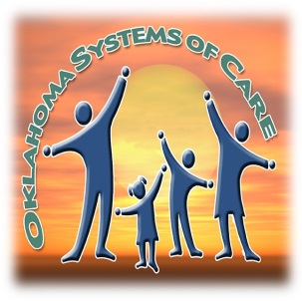
Edwin Fair CMHC
Oklahoma Systems of Care Enrollment

Guardian has given verbal permission to release contact information to:
E-TEAM at the University of Oklahoma (for service evaluation)
Oklahoma Children’s Behavioral Health Network (for family support)

Service Type: Wraparound Service Coordination BISS
Juvenile Justice DHS Embed Navigate
Funding Type: Health Home (Bundled Rate) Medicaid (Non-Bundled Rate) ODMHSAS (Fee for Service)
Special Project? ONIT O-YAY
Site: Enrollment Date: / /
Client’s Legal Name: ______ _ Client’s Preferred Name: ____________________________
Date of Birth: / / Gender: ___
Medicaid #: Social Security #:
School STN #: SOC ID: __________
(if OJA/JSU involved) JOLTS #: ____ (if DHS involved) OKDHS KIDS #: _
Race / Ethnicity: (Check all that apply.)
White Black / African American Asian Other (Specify): ___
Hispanic/Latino American Indian: Enrolled Tribe
Address:
City: County: State: Zip Code:
Primary Phone: Secondary Phone:
Is caregiver of client a veteran? Yes No
DSM-5 Primary Diagnosis (if available):
Substance Abuse Diagnosis (if applicable / available):
Developmental Diagnosis (if applicable / available):

For dependent children or youth:
Caregiver 1 Name: Relationship to Child:
Caregiver 2 Name: Relationship to Child:

Enter data at: systemsofcare.ou.edu. If you have questions, please email the E-TEAM YIS Help Desk at yis.eteam@ou.edu.

